

Bulk Print Pallet Labels

1. Log Into Qargo
2. Orders
3. Print

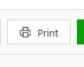

1. 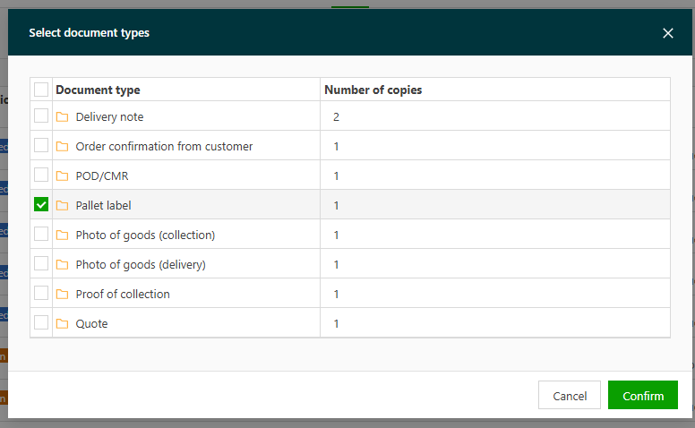Select Pallet Label
2. Select which labels you want to print

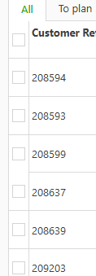

1. Print Selected Documents

