

Print Delivery Manifest

1. Log Into Qargo
2. Orders
3. Export – Portal Delivery Manifest – Select Rows

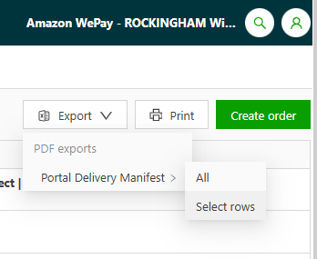

1. Select which Orders you want on the manifest

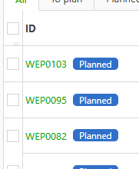

1. Export

